veepooSDK_Bug feedback document

Secret level: for partner use only
Edit: Li Jinliang
Time: 2017-07-27

Bug feedback request 2
Basic information 3
1.Description number 3
2.Describe device version 3
3.Describe SDK version 3
Summary 3
Operation description 3
4.Log 4
1. Open the log 4
2. Generate logs 4
3. Enter the log 4
4. Close the log 4
Five, feedback examples 5

Bug feedback request

When developers use our SDK, they will definitely find some bugs and provide feedback. In order to improve the efficiency of our company in resolving bugs and to reduce the cost of communication with each other, our company requires developers to include bugs in feedback The following contents:
- Basic information
- Brief description
- Operation description
- Log

Basic information

1.Description number

2.Describe device version

3.Describe SDK version
such as:
- Equipment number = 169,
- Device version = '00.30.03'；
3、Andoird sdk version：1.0.6

Summary
Explain the problem

such as:
When I call the read new alarm function, there is no return, and the device supports the new alarm function, and I have set an alarm on the watch. Is there a bug in the SDK's method of reading the new alarm?

Operation description
1. After connecting the watch, send password verification operation
2. Call the add alarm method
3. Call the read alarm method
4. Call the modify alarm method
5. Call the read alarm method

4.Log

1. Open the log
When debugging the version, you need to open the log, VpLogger.setDebug (true).

2. Generate logs
Tag is veepoo-bluetooth, which means Bluetooth layer log;
Tag is veepoo-profile: indicates a custom protocol layer log;

3. Enter the log
Developers are required to export logs from the console, preferably to our company as an attachment.txt file

4. Close the log
When you release the version, remember to close the log, VpLogger.setDebug (false);

Five, feedback examples
- Folder

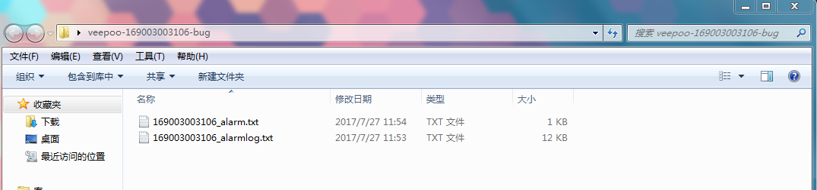
- file

